Yarranlea Primary School Annual Report 2021

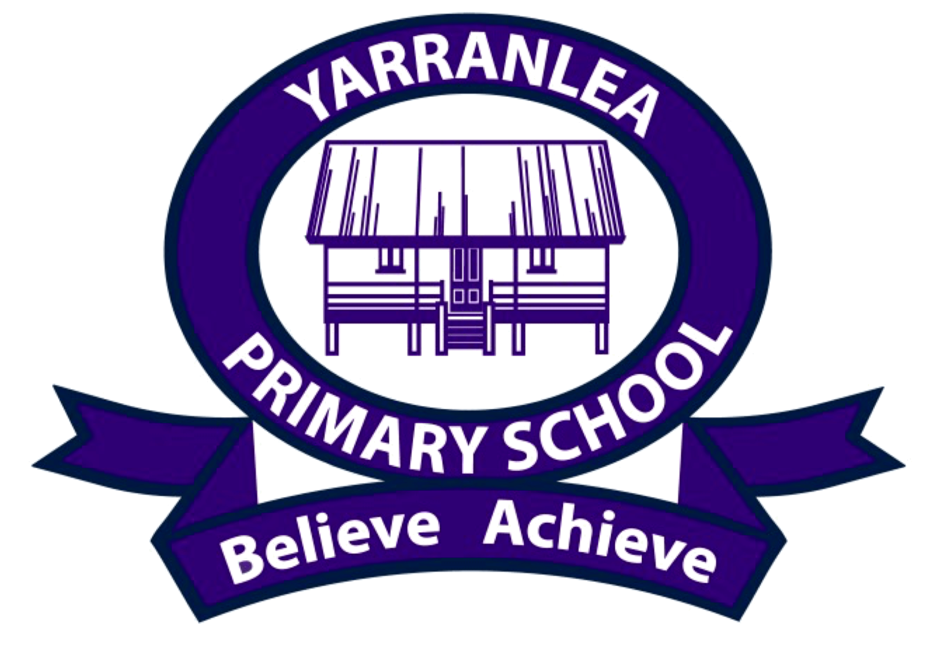

Based on 2020 Data

Table of Contents

Yarranlea Primary School Annual Report 2021 3
General School Information 3
Characteristics of the Student Body 4
Distinctive Curriculum Offerings 4
Extra-curricular Activities 4
Social Climate 5
Parental Involvement 5
Parent, Teacher and Student Satisfaction with the School 5
Contact Person for Further Information 6
School Income Broken Down by Funding Source 6
Staffing Information 6
Qualifications of all Teachers: 6
Proportion of teaching staff retained from the previous year 7
Key Student Outcomes 7
NAPLAN results for Years 3 and 5 in 2020 8
Other Information 8

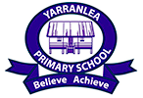
Yarranlea Primary School Annual Report 2021
(Based on 2020 data)
Yarranlea Primary School is an independent school situated within Griffith University’s Mount Gravatt Campus in Brisbane, Australia.
Philosophy
Yarranlea is a small, student-focused school operating in a conventional classroom setting that tailors the Australian National Curriculum to enable personalised learning. Teachers facilitate excellent educational outcomes relative to the unique skills and abilities of each student. It is an independent organisation that values a learning partnership between students, their families and teachers. This represents the basis of our community, where we constructively work with each other to enable our students to believe in themselves and to achieve their potential.
Vision
Success with a SMILE (Small, Multi-age, Inspirational, Learning Environment).
Values
Positivity, Integrity, Respect and Responsibility (PIRR) are the “critical few” principles that should always guide our behaviour at Yarranlea. Our ‘CARES’ framework (Courteous and Considerate, Appreciative, Responsible, Excellence and Shares) is used to create a positive environment which encourages responsible behaviour both within the school environment and within our wider community, ensuring that we remain true to our core values as we strive to equip our students with the skills for the future.

General School Information
School Sector:
Independent
School’s Address:
Griffith University Mount Gravatt Campus 176 Messines Ridge Road, Mt Gravatt, Q 4122
Total Enrolments:
2020 student numbers remained stable, ranging from 32 students at the beginning of the year to 33 students at the end of the year.

Year Levels Offered:
Prep – Year 6
Co-educational or Single Sex:
Co-educational

Characteristics of the Student Body
Yarranlea Primary School is co-educational, with approximately the same number of boys and girls. The make-up of our student body is reflective of the diverse cultural backgrounds found in Australia. Within our student body we have students with an Australian, ATSI, European, Asian and Anglo cultural background.

Distinctive Curriculum Offerings
Yarranlea is a small, student-focused, independent school, operating in a conventional classroom setting, located on a university campus. Yarranlea Primary School’s teaching is delivered in a unique multi-age setting by highly experienced teachers, with a favourable student/teacher ratio that is difficult to find at other schools. Our committed teachers and generous teaching ratios allow for a personalised approach which provides the scaffolding that surrounds the implementation of the Australian National Curriculum, harnessing the potential of each child. Yarranlea values a learning partnership between students, their families and teachers and we work constructively with each other to enable our students to believe in themselves and to achieve their potential.
2020 was a year like no other with the interruption to programs due to COVID-19, however Yarranlea Primary school still offered thetrue strength of multi-age, allowing students of different ages and abilities to collaborate in on-line projects. Yarranlea aims to equip our teachers and students with the best resources available and technology is integrated across the curriculum with school provided devices for all students. Japanese and Music are taught to all students from Prep to Year 6.

Extra-curricular Activities
Students attend swimming lessons at Griffith University’s pool as well as participating in other sporting activities such as touch football and soccer which are held on GU sporting grounds, adjacent to the school premises. Other extra-curricular activities include debating and participating in events such as Opti-MINDS.
Yarranlea continues to build its music program by providing students with musical instruments and two weekly in-class music lessons. All students sing in a choir and play musical instruments to an audience on a regular basis and all students participate in a musical at the end-of-year community event since students feel more strongly about music when they actively participate in a performance-centered music program, focused on performance by individuals, a choir and instrumental ensembles.

Social Climate
Multi-age education develops self-esteem and fosters positive attitudes towards schooling by developing students’ social, emotional and communication skills. A multi-age setting significantly reduces instances of bullying. The school has a supportive community and family atmosphere. Parent information sessions are held on current issues within the school. Policies and procedures are in place to ensure all at the school are committed to responsible behaviour and child protection.

Parental Involvement
Parents, extended family and friends are actively involved in the life of the school with social and community events, sporting carnivals and fundraising. This is coordinated by the Principal through a P&F.
Some parents, grandparents and friends of the school offer their services as volunteers to assist reading and other school related activities. The School Board is comprised of members of the wider community and past parents from the school.

Parent, Teacher and Student Satisfaction with the School
Yarranlea Primary School conducted its sixth annual survey in 2020. The Yarranlea Limited Board engaged educator and experienced consultant, Steve Francis, to independently survey three important groups in our community. The results indicated high satisfaction levels with all sections of the school community.

The main feedback from the survey indicated:

- The 2020 survey results sustained satisfaction in all areas and overwhelmingly the best things identified about our school were its small size and the nature of its community. Our Principal and teachers are regarded as being friendly and approachable, taking a genuine interest in each child and making all children and guardians feel welcome.
- Personalised learning and our low student to teacher ratio is also highly valued and the teaching staff are regarded as being committed to the best possible education for each child.
- The purpose of any survey is, of course, to identify areas where things can be improved. From this feedback we have developed a new capital improvement plan for the addition of a new classroom in 2021 which will provide state of the art facilities for Yarranlea students.

More detail on this survey was provided to the community and is available from the Principal.

Contact Person for Further Information
Mr David Costin, Principal

School Income Broken Down by Funding Source
Please refer to the My School website http://www.myschool.edu.au/ for financial data. Alternatively, the Audited Financial Report for Yarranlea Limited for 2020 is available on the Australian Charities and Not-for-Profit Commission website http://www.acnc.gov.au/

Staffing Information
Staff Composition, Including Indigenous Staff:

One part-time teaching Principal
One part time classroom and Japanese teacher
One part time classroom and music teacher
Three part-time classroom teachers

Qualifications of all Teachers:
Qualification | Either detail the number or the percentage of classroom teachers and school leaders at the school who hold this qualification
Doctorate or higher
Masters | 1
Bachelor Degree | 5
Diploma
Certificate

Proportion of teaching staff retained from the previous year
Number of permanent teaching staff at end of previous year | Number of these staff retained in the following year (the program year) | % retention rate
5 | 4 | 80%
From the end of 2019, 80% of staff were retained for the entire 2020 school year.

Key Student Outcomes
Average student attendance rate (%) for the whole school:

The average attendance rate for the whole school as a percentage in 2020 was 93.55%

Average student attendance rate for each year level:

Year levels | Average attendance rate for each year level as a percentage in 2019
Year Prep | 93.67%
Year One | 94.06%
Year Two | 95.53%
Year Three | 92.64%
Year Four | 92.98%
Year Five | 94.11%
Year Six | 90.00%

Management of non-attendance by the school:
As a small school with close relationships with families, non-attendance is managed by contacting parents of children who are absent, where the family has not already made contact to notify the school of the child’s absence. Our Principal ensures that any absences are consistent with the health and well-being of the student concerned.

NAPLAN results for Years 3 and 5 in 2020
NAPLAN testing was not completed in 2020 due to COVID-19.

Other Information
Our achievements in 2020 include:
- development and provision of exceptional learning-from-home programs due to COVID-19 closures of schools across Brisbane
- investment of significant capital funds to provide all students with state of art devices, including Surface Go’s to facilitate learning-from-home in an effective manner
- maintaining a collaborative and supportive working environment for our staff by providing additional teacher resources during 2020 to cater for increased workloads associated with COVID-19 pandemic and learning-from-home units of work
- working with our IT service provider to deliver responsive IT support to all students during government mandated learning-from-home periods
- achieving a stronger than anticipated financial result for 2020 as a result of maintaining student enrolments during a difficult financial environment
- continuing support of community enhancing activities such as provision of community care packs throughout 2020 to remain connected with students, parents, friends and care-givers during periods of enforced isolation due to the pandemic
- improved board governance through increased regularity of board meetings to ensure that risks (in particular those associated with the pandemic) were monitored and managed appropriately
- continued to provide an instrumental music program, including an online musical program during periods of school closure and learning-from-home government mandates
- Supported our highly skilled and experienced Principal and OSHC director to navigate the school and the OSHC service during a tumultuous year
- Developing a new capital improvement plan for the addition of a new classroom in 2021 involving the closing in and extension of the existing CAD building which will provide state of the art facilities for our third classroom and disability access when required and provide Yarranlea with the ability to increase enrolments as required.

Appreciation for great effort
With such a difficult year requiring professional leadership a lot was achieved by our small community and we wish to thank and acknowledge those involved: our Principal, OSHC Director and Business Manager, the teachers, the Administration and OSHC staff, the students and our fabulous parents, friends and care-givers. Thank you for helping Yarranlea remain true to our philosophy and to achieve our objectives.
Objectives for 2021 and beyond include:
As much as 2020 has been about change and adapting to “the new normal”, Yarranlea remains focused on executing our long-term growth strategies and building on our strengths: delivering educational excellence in a multi-age setting. A key objective is the development and endorsement of an updated strategic plan that covers 2021-2025 to further capitalises on the opportunity to reimagine learning in the future, that promotes organisational sustainability by providing facilities that supports future growth, supports educational excellence and mutually beneficial collaborative partnerships.
Our strategies for achieving our objectives
The strategies by which the Yarranlea Ltd board, Yarranlea Primary School and OSHC staff will achieve these objectives include:

Strategy 1: Continuing to strengthen organisational sustainability by:

- actively engaging in community partnerships that are mutually reinforcing, such as support of community enhancing activities including the P&F group
- improving website and social media presence including improving our platforms and training staff to enhance our online profile and a marketing plan for school and OSHC
- improving board governance by -
- monitoring of risk management plans
- continued focus on director succession planning
- working within the approved 2021 budget to provide sustainable teaching and support staffing levels reflected by student enrolments and a commitment to low student to teacher ratio
- maintaining existing facilities and resources, and upgrading the CAD to facilitate increased student numbers
- maintaining a collaborative and professionally fulfilling working environment for our staff
- focusing on OSHC to enable controlled enrolment growth whilst still maintaining outstanding programs, regulatory compliance and financial sustainability
- improving IT functionality for communication, curriculum and administration, and
- retention of students through Year 6 by actively engaging and communicating with Year 4 and 5 Parents.

Strategy 2: Embedding educational excellence by:

- moving to 3 classes with a child centered model to ensure small class sizes, high teaching quality and student wellbeing
- offering Japanese immersion and extension opportunities for both our native and non-native speakers across both the school and OSHC
- facilitating an open and positive approach to inquiry learning
- continuously improving teaching quality and curriculum extension, enrichment and innovation including music, and
- drawing on expertise available within Yarranlea and Universities to investigate and to apply best-fit practice in multi-age teaching.
Strategy 3: Extending and deepening Yaranlea Ltd’s learning partnerships and community collaboration by:
- building strong relationships with key politicians, government, regulatory authorities and Griffith University management
- establishing a building fund
- exploring a relationship with the digital and social media marketing course at Griffith University to have Yarranlea primary school students working with Griffith staff to increase brand awareness
- connecting with kindergartens, childcare centres and building relationships with the local high schools to assist with Year 6 students’ transition
- connecting with other providers of Japanese language education including Holland Park High School and the weekend operators of schools for children with Japanese heritage, and
- forging alliances with like-minded schools in Australia and internationally

