Yarranlea Primary School Annual Report 2020

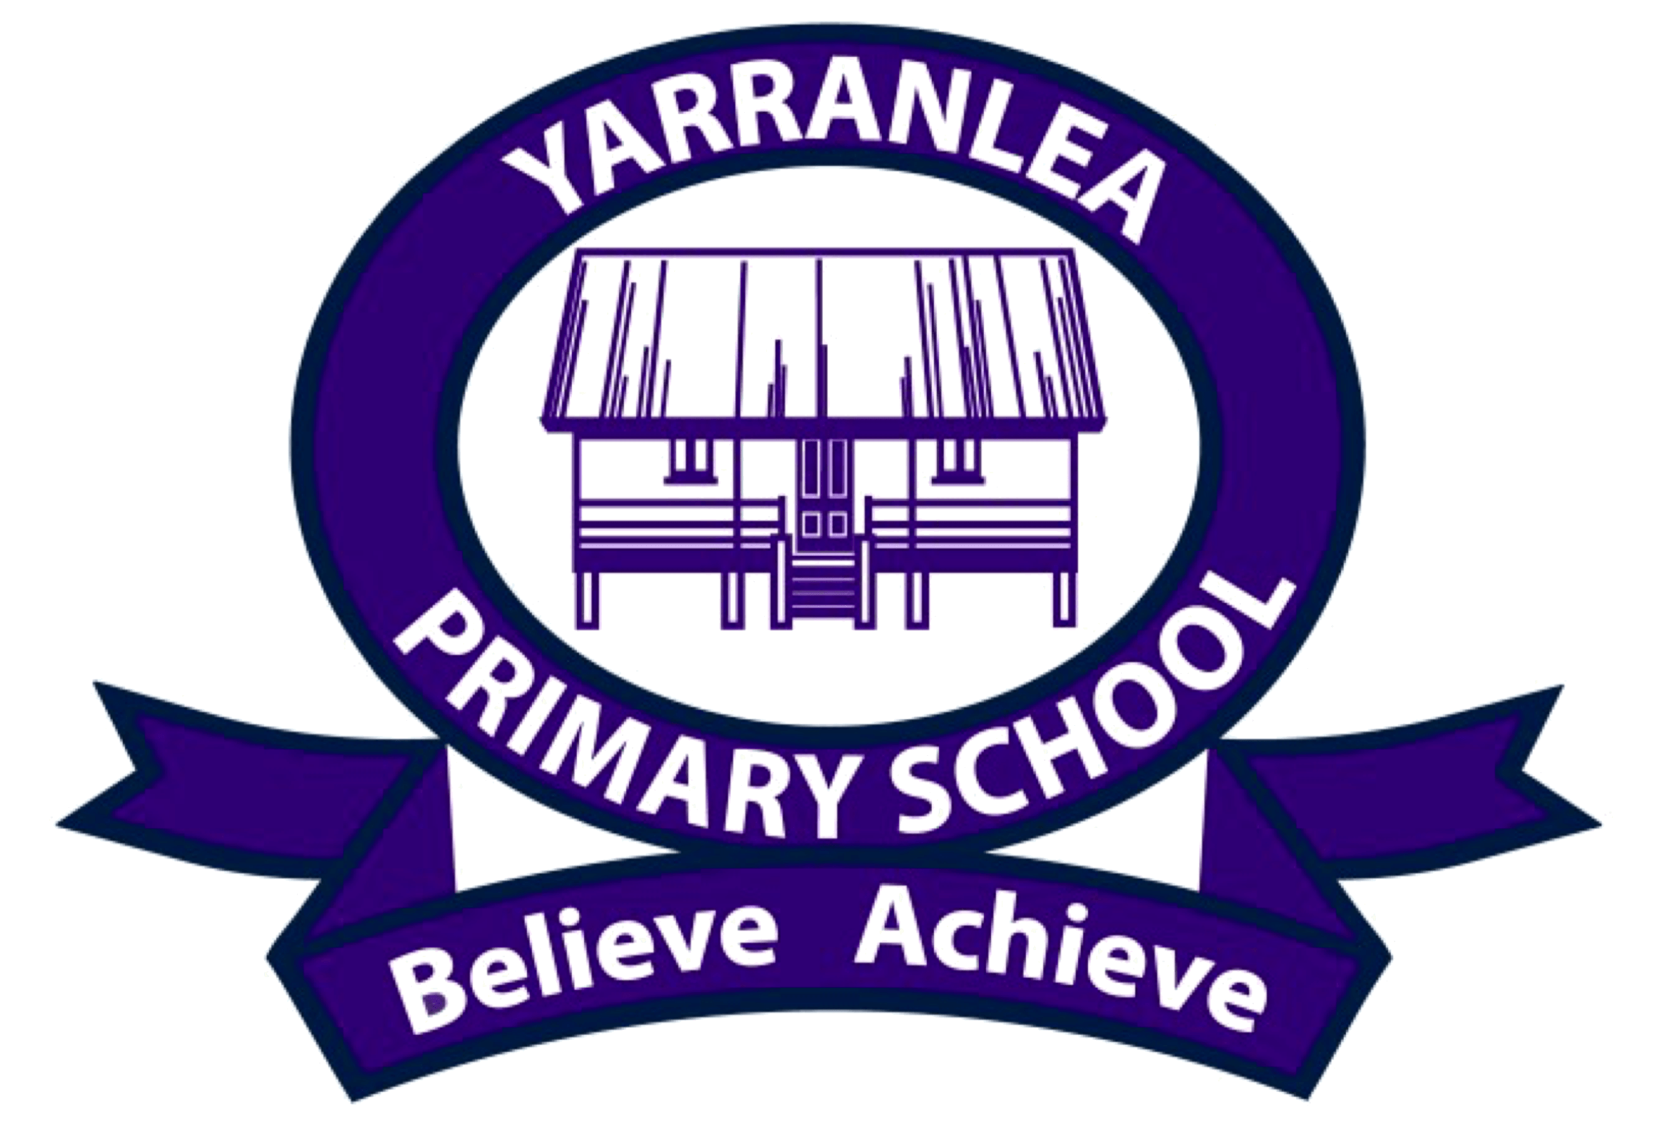

Based on 2019 Data

Table of Contents

Yarranlea Primary School Annual Report 2020 3
General School Information 3
Characteristics of the Student Body 4
Distinctive Curriculum Offerings 4
Extra-curricular Activities 4
Social Climate 5
Parental Involvement 5
Parent, Teacher and Student Satisfaction with the School 5
Contact Person for Further Information 6
School Income Broken Down by Funding Source 6
Staffing Information 6
Qualifications of all Teachers: 6
Proportion of teaching staff retained from the previous year 7
Key Student Outcomes 7
NAPLAN results for Years 3 and 5 in 2019 8
Other Information 8

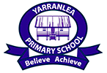
Yarranlea Primary School Annual Report 2020
(Based on 2019 data)
Yarranlea Primary School is an independent school situated within Griffith University’s Mount Gravatt Campus in Brisbane, Australia.
Philosophy
Yarranlea is a small, student-focused school operating in a conventional classroom setting that tailors the Australian National Curriculum to enable personalised learning. Teachers facilitate excellent educational outcomes relative to the unique skills and abilities of each student. It is an independent organisation that values a learning partnership between students, their families and teachers. This represents the basis of our community, where we constructively work with each other to enable our students to believe in themselves and to achieve their potential.
Vision
Success with a SMILE (Small, Multi-age, Inspirational, Learning Environment).
Values
Positivity, Integrity, Respect and Responsibility (PIRR) are the “critical few” principles that should always guide our behaviour at Yarranlea. Our ‘CARES’ framework (Courteous and Considerate, Appreciative, Responsible, Excellence and Shares) is used to create a positive environment which encourages responsible behaviour both within the school environment and within our wider community, ensuring that we remain true to our core values as we strive to equip our students with the skills for the future.

General School Information
School Sector:
Independent
School’s Address:
Griffith University Mount Gravatt Campus 176 Messines Ridge Road, Mt Gravatt, Q 4122
Total Enrolments:
2019 student numbers remained stable, ranging from 31 students at the beginning of the year to 32 students at the end of the year.

Year Levels Offered:
Prep – Year 6
Co-educational or Single Sex:
Co-educational

Characteristics of the Student Body
Yarranlea Primary School is co-educational, with approximately the same number of boys and girls. The make-up of our student body is reflective of the diverse cultural backgrounds found in Australia. Within our student body we have students with an Australian, ATSI, European, Asian and Anglo cultural background.

Distinctive Curriculum Offerings
Yarranlea is a small, student-focused, independent school, operating in a conventional classroom setting, located on a university campus. Yarranlea Primary School’s teaching is delivered in a unique multi-age setting by highly experienced teachers, with a favourable student/teacher ratio that is difficult to find at other schools. Our committed teachers and generous teaching ratios allow for a personalised approach which provides the scaffolding that surrounds the implementation of the Australian National Curriculum, harnessing the potential of each child. Yarranlea values a learning partnership between students, their families and teachers and we work constructively with each other to enable our students to believe in themselves and to achieve their potential.
During 2019, collaboration with professional organisations allowed for a successful STEAM program at Yarranlea which has tapped into the true strength of multi-age, allowing students of different ages and abilities to collaborate in STEAM projects. Yarranlea aims to equip our teachers and students with the best resources available and technology is integrated across the curriculum with school provided devices for all students. Japanese and Music are taught to all students from Prep to Year 6.

Extra-curricular Activities
Students attend swimming lessons at Griffith University’s pool as well as participating in other sporting activities held on the school premises. Other extra-curricular activities include debating and participating in events such as Opti-MINDS.
Yarranlea’s instrumental music program continues to grow from strength to strength with school provided musical instruments and two weekly in-class music lessons. All students sing in a choir and play musical instruments to an audience on a regular basis. In addition, all students participate in a musical at the end-of year.

Social Climate
Multi-age education develops self-esteem and fosters positive attitudes towards schooling by developing students’ social, emotional and communication skills. A multi-age setting significantly reduces instances of bullying. The school has a supportive community and family atmosphere. Parent information sessions are held on current issues within the school. Policies and procedures are in place to ensure all at the school are committed to responsible behaviour and child protection.

Parental Involvement
Parents, extended family and friends are actively involved in the life of the school with social and community events, sporting carnivals and fundraising. This is coordinated by the Principal through a P&F.
Some parents, grandparents and friends of the school offer their services as volunteers to assist reading and other school related activities. The School Board is comprised of members of the wider community and past parents from the school.

Parent, Teacher and Student Satisfaction with the School
Yarranlea Primary School conducted its fifth annual survey in 2019. The Yarranlea Limited Board engaged educator and experienced consultant, Steve Francis, to independently survey three important groups in our community. The results indicated high satisfaction levels with all sections of the school community.

The main feedback from the survey indicated:

- The 2019 survey results sustained satisfaction in all areas and overwhelmingly the best things identified about our school were its small size and the nature of its community. Our Principal and teachers are regarded as being friendly and approachable, taking a genuine interest in each child and making all children and guardians feel welcome.
- Personalised learning and our low student to teacher ratio is also highly valued and the teaching staff are regarded as being committed to the best possible education for each child.
- The purpose of any survey is, of course, to identify areas where things can be improved. From this feedback major capital improvements of $33,000 were incurred to install artificial turf to the school oval allowing significantly better use of the oval.
- Collaboration with our P&F group resulted in a major capital improvement project of $104,000 to upgrade the bathroom facilities to provide larger restroom facilities and improved accessibility for all. The project was proudly supported and jointly funded 50/50 by an Access and Inclusion Community Program grant from Brisbane City Council.
More detail on this survey was provided to the community and is available from the Principal.

Contact Person for Further Information
Mr David Costin, Principal

School Income Broken Down by Funding Source
Please refer to the My School website http://www.myschool.edu.au/ for financial data. Alternatively, the Audited Financial Report for Yarranlea Limited for 2019 is available on the Australian Charities and Not-for-Profit Commission website http://www.acnc.gov.au/

Staffing Information
Staff Composition, Including Indigenous Staff:

One part-time teaching Principal
One part time classroom and Japanese teacher
One part time classroom and music teacher
Two part-time classroom teachers

Qualifications of all Teachers:
Qualification | Either detail the number or the percentage of classroom teachers and school leaders at the school who hold this qualification
Doctorate or higher
Masters | 1
Bachelor Degree | 4
Diploma
Certificate

Proportion of teaching staff retained from the previous year
Number of permanent teaching staff at end of previous year | Number of these staff retained in the following year (the program year) | % retention rate
5 | 5 | 100%
From the end of 2018, 100% of staff were retained for the entire 2019 school year.

Key Student Outcomes
Average student attendance rate (%) for the whole school:

The average attendance rate for the whole school as a percentage in 2019 was 92.84%

Average student attendance rate for each year level:

Year levels | Average attendance rate for each year level as a percentage in 2019
Year Prep | 94.45%
Year One | 92.35%
Year Two | 92.30%
Year Three | 92.19%
Year Four | 92.52%
Year Five | 89.62%
Year Six | 96.98%

Management of non-attendance by the school:
As a small school with close relationships with families, non-attendance is managed by contacting parents of children who are absent, where the family has not already made contact to notify the school of the child’s absence. Our Principal ensures that any absences are consistent with the health and well-being of the student concerned.

NAPLAN results for Years 3 and 5 in 2019
To assure the privacy of individual students we do not report on NAPLAN results as our school has small enrolment numbers. Please refer to the My School website http://www.myschool.edu.au/ for NAPLAN information.

Other Information
Our achievements in 2019 include:
- Successfully completed our first NSSAB cyclic review
- Continued support of community enhancing activities including the P&F group
- Improved board governance by
  - active participation in the NSSAB cyclic review
  - monitoring of risk management plans
  - renewed focus on director succession planning
- Worked within the approved 2019 budget providing sustainable teaching and support staffing levels reflected by student enrolments and a low student to staff teaching ratio
- Achieved a strong financial result for 2019 as a result of student enrolments growing
- Continued to provide an instrumental music program providing musical instruments for each student and two weekly in-class music lessons,
- Continued to offer a one to one device program providing
    - Ipads for Prep to Year 2 classes
    - Laptops for Year 3 to Year 6 classes,
- Continued our research partnerships with Griffith University, building upon our multi-age literature review,
- Operated with our established Principal, bringing continued stability and prior experience as a Principal to the role,
- Supported our highly skilled and experienced OSHC director with the skills to run and be fully accountable and responsible for the OSHC service, resulting in improved sustainability,
- Conducted our fifth independent survey indicating high satisfaction levels among all stakeholder groups, and
- Undertook capital improvements of $104,000 to upgrade the bathroom facilities to provide larger restroom facilities and improved accessibility for all. The project was proudly supported and jointly funded 50/50 by an Access and Inclusion Community Program grant from Brisbane City Council.
- Undertook further capital improvements of $33,000 to install artificial turf to the school oval allowing significantly better use of the oval.

Appreciation for great effort
The board sincerely acknowledges the valuable efforts of our dedicated supporters and our leadership team in 2019. Following the trend set in prior years, a lot was achieved by a small but fantastic community of parents, relatives, care-givers, teachers, OSHC staff, support staff and volunteers in progressing Yarranlea’s philosophy and objectives.
Objectives for 2019 and beyond include:
Developing and endorsing a strategic plan 2021-2025 that capitalizes on the opportunity to reimagine learning in the future, that promotes organisational sustainability by providing facilities that supports future growth, supports educational excellence and mutually beneficial collaborative partnerships.
Our strategies for achieving our objectives
The strategies by which the Yarranlea Ltd board, Yarranlea Primary School and OSHC staff will achieve these objectives include:

Strategy 1: Continuing to strengthen organisational sustainability by:
    - Actively engaging in community partnerships that are mutually reinforcing, such as
      - support of community enhancing activities including the P&F group
      - improved online presence by maintaining the school website to a high standard
    - Improving board governance by
      - monitoring of risk management plans
      - continued focus on director succession planning
    - Working within the approved 2020 budget to provide sustainable teaching and support staffing levels reflected by student enrolments and a commitment to low teaching staff to student ratio
    - Maintaining existing facilities and resources, and upgrading existing facilities or resourcing alternative facilities to facilitate student growth
    - Maintaining a collaborative and professionally fulfilling working environment for our staff
    - Supporting OSHC to enable controlled enrolment growth whilst still maintaining outstanding programs, regulatory compliance and financial sustainability/independence
    - Monitoring IT contract and improving IT functionality for communication, curriculum and administration
    - Developing an IT Plan, and
    - Continued P&F governance by developing a P&F charter

Strategy 2: Embedding educational excellence by:
- Facilitating an open and positive approach to inquiry-based learning
- Continuously improving teaching quality and curriculum enactment
- Co-researching with Professor Donna Pendergast on the topic of multi-age teaching using Yarranlea as the focus, and
- Drawing on expertise available within Yarranlea from Griffith University to investigate and to apply best-fit practice in multi-age teaching.

Strategy 3: Extending and deepening Yarranlea Ltd’s learning partnerships and community collaboration by:
- Building strong relationships with key politicians, government, regulatory authorities and Griffith University management
- Establishing a building fund
- Supporting active Alumni and external community engagement
- Connecting with kindergartens, childcare centres and local high schools to assist with Year 6 student’s transition to high school, and
- Forging alliances with like-minded schools in Australia and internationally

