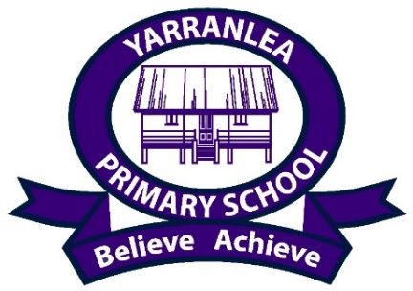

Yarranlea Primary School Uniform Order Form
Polo shirt Sizes 4 - 16 $42.00

Unisex shorts Sizes 4 - 16 $17.00
Hat Small Med Large $19.00
Jacket Sizes 4 - 14 $40.00

Please return completed forms by email to finance@yarranlea.qld.edu.au or return a printed copy to the school.
Payments should be made at the time of ordering by direct deposit. Please email bank deposit confirmation to finance@yarranlea.qld.edu.au
Yarranlea Limited BSB 034 061 Acc. 366 925

Once payment is received your uniforms will be available for collection from school.

Name:

ITEM | QUANTITY | SIZE | PRICE | TOTAL
Polo shirt |  |  | $42
Unisex shorts |  |  | $17
Hat |  |  | $19
Jacket |  |  | $40
starter pack  3 shirts, 3 shorts and a hat |  |  | $180
TOTAL

